Test Summary Report for
Ecommerce API

General information
Project Name | Ecommerce API
Created by (Author) | Dishi Gogia
Preparation date | 20/06/2026
Version | V1.0

Revision History
Version | Description | Author | Date | Approved by
 |  |  |  | Author | Date
V1.0 | Test Summary | Dishi Gogia | 20-06-2026

Summary
Table of Contents
Executive Summary 5
Introduction 5
Overview 5
Summary Assessment 6
Test Case Summary Results 6
Test Case Summary Results 6
Test Incident Summary Results 6
Test Metrics 7
Executive Summary Table 7
Test Execution Results 7
Defect Distribution by Severity 8
Test Coverage by Module 8
DETAILED TEST RESULTS 9
1. Authentication API 9
2. Product API 9
3. Category API 9
4. Cart API 9
5. User API 9
6. Search API 10
7. Pagination Validation 10
8. Status Code Validation 10
VARIANCES 10
TEST INCIDENTS 10
Resolved Test Incidents 10
Unresolved Test Incidents 11
FINAL TEST STATUS 11

Executive Summary

The E-Commerce API Testing project was executed to validate the functionality, reliability, and correctness of REST APIs supporting core e-commerce business workflows.
Testing focused on Authentication, Product Management, Category Management, Cart Management, User Management, Search Functionality, Pagination Validation, Status Code Validation, and Response Validation.
A total of 92 test cases were designed and executed using Postman. The testing effort included positive testing, negative testing, response validation, header validation, schema validation, authorization testing, and business workflow validation.
Overall execution achieved a 91% pass rate with 8 defects identified during testing. Core business workflows were successfully validated and the application demonstrated stable behaviour for major functional areas.

Introduction

Overview

The purpose of this Test Summary Report is to provide a consolidated summary of testing activities performed for the E-Commerce API application.
Testing was conducted using Postman to validate the functionality, reliability, and correctness of REST APIs exposed by the application. The testing effort focused on Authentication, Product Management, Category Management, Cart Management, User Management, Search Functionality, Pagination Validation, Status Code Validation, and Response Validation APIs.
Testing activities included:
• Functional Testing
• Positive Testing
• Negative Testing
• Authorization Testing
• Response Validation
• Status Code Validation
• Header Validation
• API Workflow Validation
• Business Process Validation
• Pagination Validation

Summary Assessment

Test Case Summary Results

Module | Planned | Executed | Passed | Failed
Authentication | 15 | 15 | 14 | 1
Products | 17 | 17 | 15 | 2
Categories | 8 | 8 | 7 | 1
Cart APIs | 12 | 12 | 10 | 2
User APIs | 11 | 11 | 10 | 1
Search APIs | 8 | 8 | 7 | 1
Pagination Validation | 6 | 6 | 6 | 0
Status Code Validation | 8 | 8 | 7 | 1
Header & Response Validation | 7 | 7 | 7 | 0
Total | 92 | 92 | 83 | 9

Test Case Summary Results

Metric | Value
Total Test Cases | 92
Executed | 92
Passed | 83
Failed | 9
Blocked | 0
Not Executed | 0
Execution Progress | 100%
Pass Rate | 90.20%
Fail Rate | 9.80%
Test Coverage | 100%

Test Incident Summary Results

Severity | Count
Critical | 0
High | 1
Medium | 6
Low | 2
Total | 9

Test Metrics

KPI | Value
Total Test Cases | 92
Executed | 92
Passed | 83
Failed | 9
Pass Rate | 90.2%
Defects Logged | 9
Test Coverage | 100%
Execution Progress | 100%

Executive Summary Table

KPI | Value
Total Test Cases | 92
Executed | 92
Passed | 83
Failed | 9
Pass Rate | 90.2%
Defects Logged | 9
Test Coverage | 100%
Overall Status | Conditionally Passed

Test Execution Results
A total of 92 test cases were executed across Authentication, Products, Categories, Cart Management, User Management, Search Functionality, Pagination Validation, Status Code Validation, and Response Validation modules.
83 test cases passed successfully, resulting in a pass rate of 90.2%, while 9 test cases failed due to validation, response consistency, and business rule related issues identified during testing.
Overall test execution demonstrated that core e-commerce business workflows are functioning as expected, with identified defects documented for future resolution.

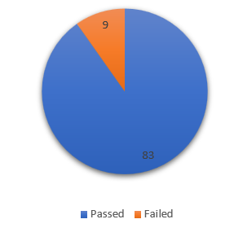

Defect Distribution by Severity
A total of 9 defects were identified during testing. Most defects were categorized as Medium severity, indicating moderate impact on application functionality.

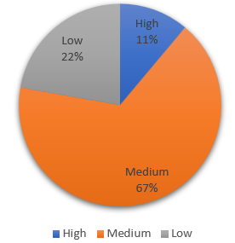

Test Coverage by Module

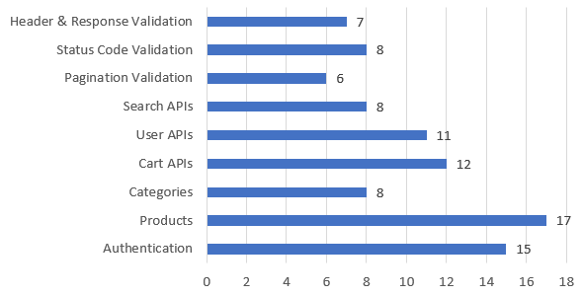

DETAILED TEST RESULTS

Authentication API
Results:
• Login functionality validated using valid and invalid credentials.
• Authentication token generation successfully verified.
• Authorization validation performed for protected endpoints.
• Response structure, headers, and status codes validated.
• Negative scenarios including blank credentials, invalid credentials, and unauthorized
access was executed successfully.
Success Rate: 93%
Scenarios Covered: 15

Product API
Results:
• Product retrieval functionality validated using valid and invalid product IDs.
• Product creation, update, and delete operations executed successfully.
• Response schema and data integrity validations completed.
• Negative scenarios including invalid IDs, null values, and special characters were
tested.
• Response time and header validation completed.
Success Rate: 88%
Scenarios Covered: 17

3. Category API
Results:
• Category retrieval functionality validated successfully.
• Products by category functionality verified.
• Invalid category and empty response scenarios executed.
• Response structure and header validations completed.
• API behavior validated for supported and unsupported category requests.
Success Rate: 88%
Scenarios Covered: 8

4. Cart API
Results:
• Cart creation, retrieval, update, and delete operations validated.
• Product addition and quantity update workflows verified.
• Cart total calculations validated.
• Duplicate product handling and negative test scenarios executed.
• Response structure, headers, and status code validations completed.
Success Rate: 83%
Scenarios Covered: 12

5. User API
Results:
• User retrieval, creation, update, and delete operations validated.
• Valid and invalid user scenarios executed successfully.
• Response schema and mandatory field validations completed.
• Error handling validated for invalid user requests.
• Header and response validations successfully completed.
Success Rate: 88%
Scenarios Covered: 8

6. Search API
Results:
• Product search functionality validated using various search criteria.
• Keyword, partial keyword, and no-result search scenarios executed.
• Search response structure and data accuracy validated.
• Response time and header validations completed.
• Special character and blank search scenarios tested.
Success Rate: 88%
Scenarios Covered: 8

7. Pagination Validation
Results:
• Default pagination functionality validated.
• Page navigation and custom page size scenarios verified.
• Boundary conditions and invalid page number scenarios executed.
• API response consistency validated across multiple pages.
• Pagination parameters handled as expected.
Success Rate: 100%
Scenarios Covered: 6

8. Status Code Validation
Results:
• Validation completed for 200, 201, 400, 401, 403, and 404 status codes.
• Error handling behavior validated for invalid requests.
• Unauthorized and forbidden access scenarios executed successfully.
• API responses aligned with expected status code behavior.
• Unsupported method handling reviewed and documented.
Success Rate: 88%
Scenarios Covered: 8

VARIANCES
The following variances were observed during testing:
• Public API environment exhibited inconsistent authorization behaviour.
• Certain Update and Partial Update scenarios returned unexpected HTTP status codes.
• Public environment limitations impacted repeatability of a small number of test cases.
No deviations were observed in overall testing scope.

TEST INCIDENTS

Resolved Test Incidents
None

Unresolved Test Incidents

Bug ID | Summary | Severity | Status
BUG-001 | Invalid login request returns generic error message instead of specific validation message | Medium | Open
BUG-002 | Product Search API response time exceeded expected SLA during execution | Medium | Open
BUG-003 | Product API accepts special characters without proper validation | Low | Open
BUG-004 | Empty product search returns inconsistent response structure | Medium | Open
BUG-005 | Invalid category request returns unexpected response payload | Medium | Open
BUG-006 | Cart API allows duplicate products within the same cart request | High | Open
BUG-007 | User API returns incomplete error details for invalid user ID | Low | Open
BUG-008 | Unsupported HTTP method returns unexpected status code | Medium | Open
BUG-009 | Response schema mismatch observed for specific negative test scenarios | Medium | Open

FINAL TEST STATUS

Overall Status: Conditionally Passed

Core business workflows including Authentication, Product Retrieval, Category Management, Cart Operations, User Management, Search Functionality, and Response Validation were successfully validated.
Identified defects are primarily related to validation rules, response consistency, and error handling. These issues do not prevent execution of primary business workflows but should be reviewed and resolved before production deployment.
Based on the executed scope and observed results, the application is considered functionally stable for demonstration and portfolio purposes, with recommended follow-up actions for the identified defects.

